DIGITAL DESIGN
CS223
Section: 001
Lab3 Report
Name: Tolga Han Arslan
ID: 22003061
Date: 31.10.2022

b) Behavioral SystemVerilog module for a 1-to-2 decoder (including enable signal) and a testbench for it.

module decoder_1to2(
input en,
input s,
output y0,
output y1
);
assign y0 = ~s & en;
assign y1 = s & en;
endmodule

module decoder_1to2_tb();
logic s,en,y1,y2;
decoder_1to2 dut(en,s,y1,y2);
initial begin
s=0; en=0; #10;
s=1; #10;
en=1; s=0; #10;
s=1; #10;
end
endmodule

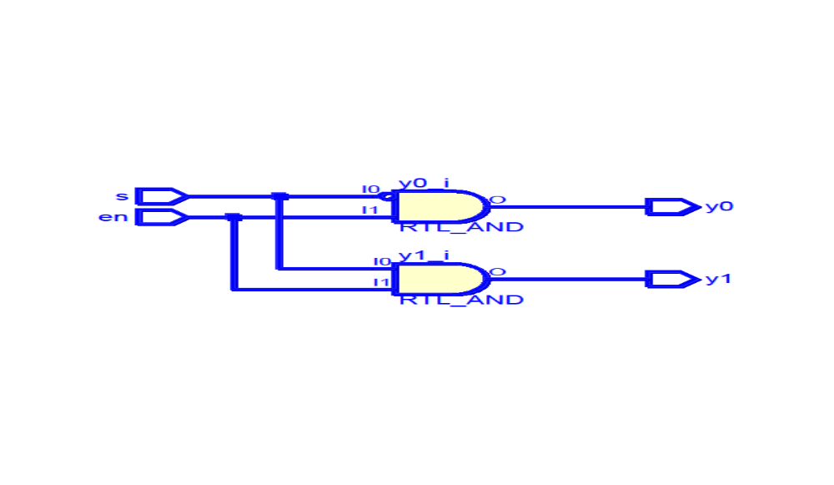

c) Structural SystemVerilog module for a 2-to-4 decoder (including enable signal) using three 1-to-2 decoders. Prepare a testbench for it.

module decoder_2to4(
input en,
input s0,
input s1,
output out0,
output out1,
output out2,
output out3
);
logic y0,y1;
decoder_1to2 decoder1(en,s0,y0,y1);
decoder_1to2 decoder2(y0,s1,out0,out1);
decoder_1to2 decoder3(y1,s1,out2,out3);
endmodule

module decoder_2to4_tb();
logic en,s0,s1,y0,y1,y2,y3;
decoder_2to4 dut(en,s0,s1,y0,y1,y2,y3);
initial begin
en=0; s0=0; s1=0; #10;
s1=1; #10;
s1=0; s0=1; #10;
s1=1; #10;
en = 1; s0=0; s1=0; #10;
s1=1; #10;
s0=1; s1=0; #10;
s1=1; #10;
end
endmodule
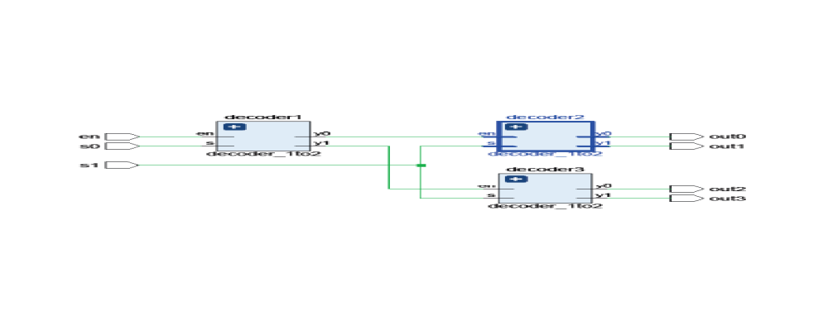
d) Behavioral SystemVerilog module for a 2-to-1 multiplexer.

module mux2(
input logic d0, d1,
input logic s,
output logic y
);
assign y = s ? d1: d0;
endmodule

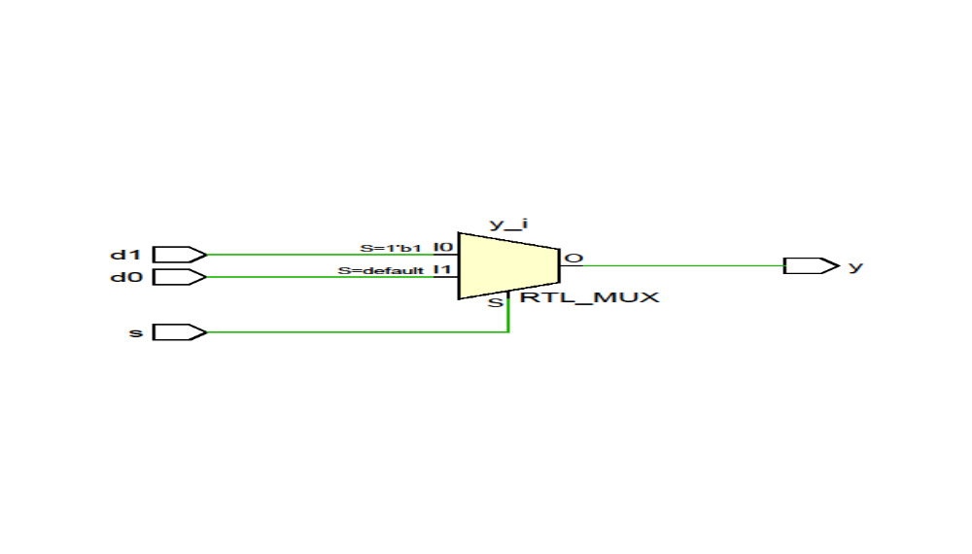

e) Structural SystemVerilog module for a 4-to-1 multiplexer using three 2-to-1 multiplexers. Prepare a testbench for it.
module mux4(
input i0,
input i1,
input i2,
input i3,
input s0,s1,
output out
);
logic y1,y2;
mux2 lowmux(i0,i1,s0,y1);
mux2 highmux(i2,i3,s0,y2);
mux2 endmux(y1,y2,s1,out);
endmodule

module mux4_tb();
logic i0,i1,i2,i3;
logic s0, s1;
logic out;
mux4 dut(i0,i1,i2,i3,s0,s1,out);
initial begin
s0=0; s1=0; i0=0; i1=0; i2=0; i3=0; #10;
i3=1; #10;
i3=0; i2=1; #10;
i3=1; #10;
i3=0; i2=0; i1=1; #10;
i3=1; #10;
i3=0; i2=1; #10;
i3=1; #10;
i0=1; i1=0; i2=0; i3=0; #10;
i3=1; #1;
i3=0; i2=1; #10;
i3=1; #10;
i1=1; i2=0; #10; i3=0; #10;
i3=1; #10;
i3=0; i2=1; #10;
i3=1; #10;
s1=1; i0=0; i1=0; i2=0; i3=0; #10;
i3=1; #10;
i3=0; i2=1; #10;
i3=1; #10;
i3=0; i2=0; i1=1; #10;
i3=1; #10;
i3=0; i2=1; #10;
i3=1; #10;
i0=1; i1=0; i2=0; i3=0; #10;
i3=1; #1;
i3=0; i2=1; #10;
i3=1; #10;
i1=1; i2=0; #10; i3=0; #10;
i3=1; #10;
i3=0; i2=1; #10;
i3=1; #10;
s1=0; s0=1; i0=0; i1=0; i2=0; i3=0; #10;
i3=1; #10;
i3=0; i2=1; #10;
i3=1; #10;
i3=0; i2=0; i1=1; #10;
i3=1; #10;
i3=0; i2=1; #10;
i3=1; #10;
i0=1; i1=0; i2=0; i3=0; #10;
i3=1; #1;
i3=0; i2=1; #10;
i3=1; #10;
i1=1; i2=0; #10; i3=0; #10;
i3=1; #10;
i3=0; i2=1; #10;
i3=1; #10
s1=1; i0=0; i1=0; i2=0; i3=0; #10;
i3=1; #10;
i3=0; i2=1; #10;
i3=1; #10;
i3=0; i2=0; i1=1; #10;
i3=1; #10;
i3=0; i2=1; #10;
i3=1; #10;
i0=1; i1=0; i2=0; i3=0; #10;
i3=1; #1;
i3=0; i2=1; #10;
i3=1; #10;
i1=1; i2=0; #10; i3=0; #10;
i3=1; #10;
i3=0; i2=1; #10;
i3=1; #10;
end
endmodule
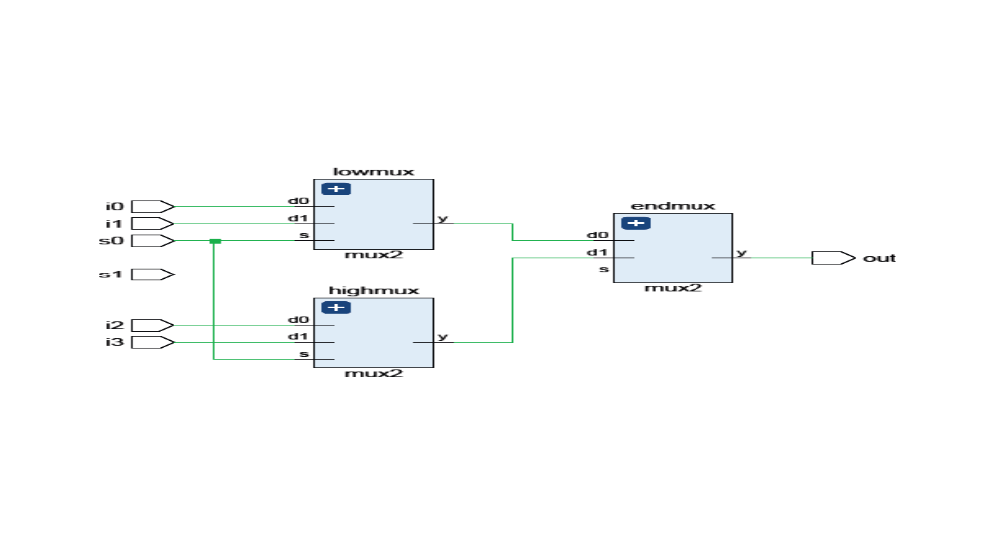
f) Block diagram and structural System Verilog module of 8-to-1 MUX by using two 4-to-1 MUX modules, two AND gates, an INVERTER, and an OR gate.
module mux8(
input i0,
input i1,
input i2,
input i3,
input i4,
input i5,
input i6,
input i7,
input s0,
input s1,
input s2,
output out
);
logic r0,r1;
mux4 muxlow(i0,i1,i2,i3,s0,s1,r0);
mux4 muxhigh(i4,i5,i6,i7,s0,s1,r1);
logic a,b,c;
not not_1(a,s2);
and and_1(b,r0,a);
and and_2(c,r1,s2);
or or_1(out,b,c);
endmodule

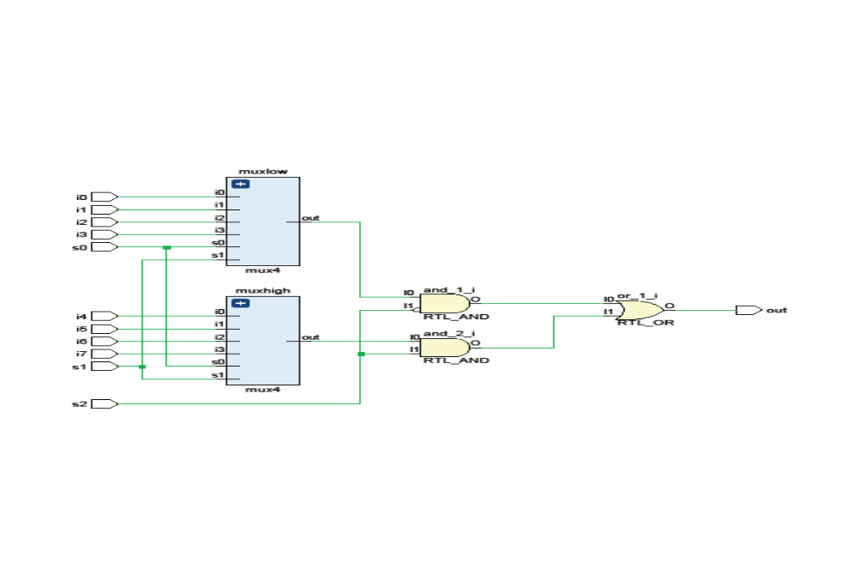

g) Block diagram and SystemVerilog module for the function F, using only one 8-to-1 multiplexer and an INVERTER (if you wish). The function F is as follows:
F(A,B,C,D)= {1 𝑖𝑓 8<𝐴𝐵𝐶𝐷+𝐶𝐴𝐷𝐵<220 𝑜𝑡ℎ𝑒𝑟𝑤𝑖𝑠𝑒
where ABCD and CADB are 4-bit unsigned binary numbers. For ABCD, A is the most significant bit and D is the least significant bit. For CADB, C is the most significant bit and B is the least significant bit. E.g. F(0,1,0,1)=1 since ABCD=1001, CADB=0110, and ABCD+CADB =15 that results in 8 < ABCD+CADB < 22.
module bool_func(
input a,
input b,
input c,
input d,
output y
);
logic inv_c;
not(inv_c,c);
mux8 mux_1(c,c,c,c,inv_c,inv_c,inv_c,inv_c,d,b,a,y); //a and d should be reverse for s0 s1 s2
endmodule
